**Q2: explain input/ output**

**Input for the Mini-C Compiler**

The input is usually a C-like source code file, containing a subset of C programming constructs. This file includes:

1. **Basic Constructs:**
   * Variable declarations
   * Arithmetic and logical operations
   * Control structures (if-else, loops)
   * Function definitions and calls
2. **Example Input File (input1.c):**

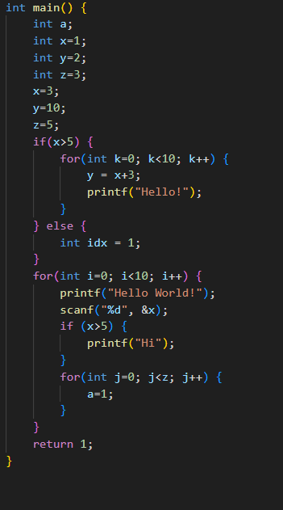

**Output of the Mini-C Compiler**

The output can vary based on the stages of compilation supported. Here's what the Mini-C Compiler might produce:

1. **Tokenized Output (Lexical Analysis):**
   * A list of tokens extracted from the source code.

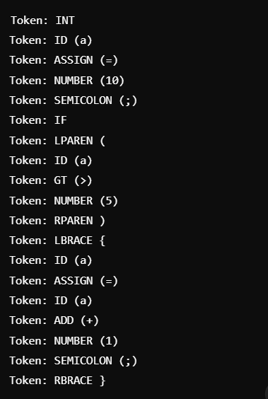

**Parse Tree or Abstract Syntax Tree (Syntax Analysis):**

* A tree structure representing the grammatical structure of the code.

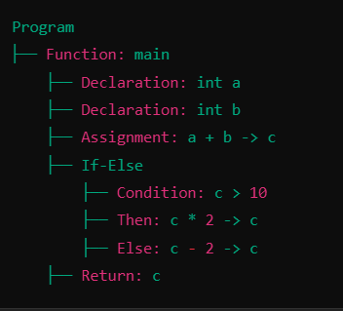

**Intermediate Representation (IR):**

* Three-address code or similar representation

